2021-2022

LOK SWAR
(Voice of people)
Annual Report

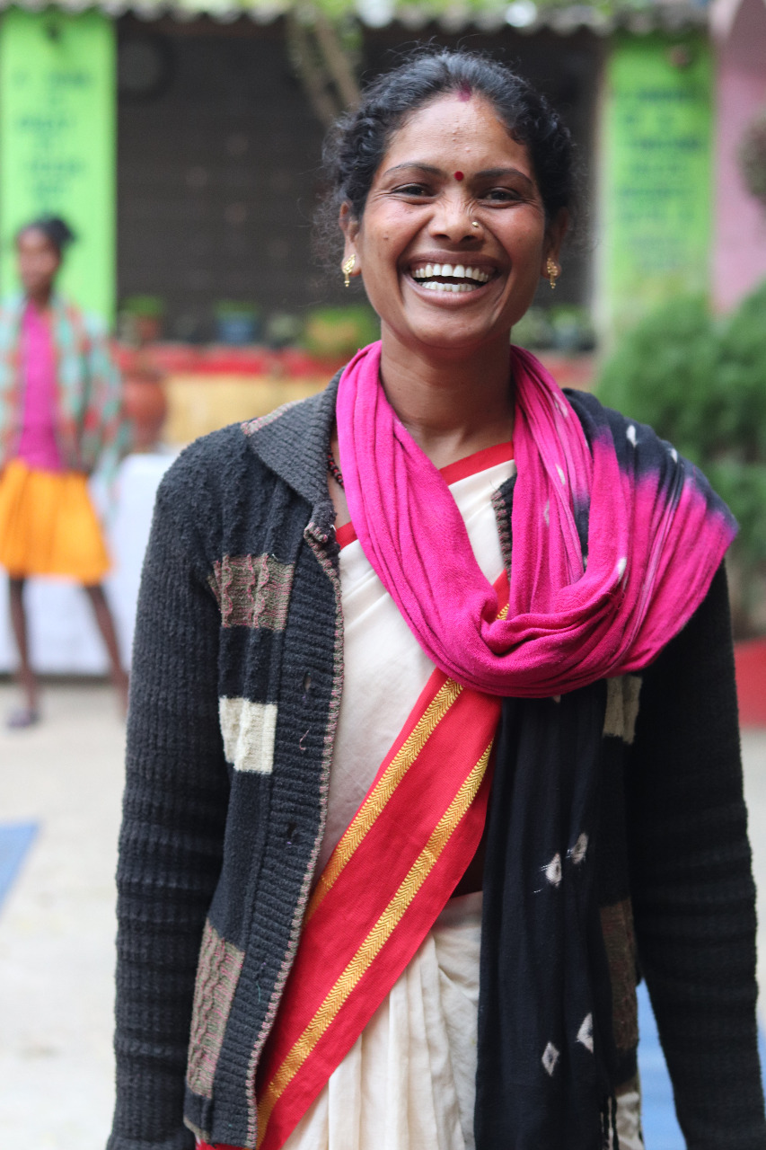
Website- www.lokswar.org
Serving communities from past 23 years

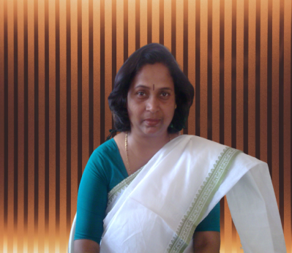
Message from the Secretary’s Desk
Dear
Supporters, Donors, and Friends,

We are delighted to present the Annual Report for 2021-2022 on behalf of LOK SWAR. As the Secretary of the organization, it is my privilege to share with you the remarkable achievements and progress made possible through your unwavering support and dedication. This year has been a testament to the power of collective effort and the profound impact we can create when we stand together. Through our collective endeavours, we have strived to address the pressing challenges faced by the communities we serve, leaving no one behind.
In the pages that follow, you will discover the stories of hope and transformation that have unfolded throughout the year. From education and healthcare initiatives to environmental conservation and social empowerment projects, each endeavour is a testament to the enduring spirit of our organization and the people who make it possible. We extend our heartfelt gratitude to all our supporters, donors, partners, and volunteers whose unwavering commitment has fuelled our endeavours. Your generosity has been the driving force behind our successes, enabling us to reach new heights and touch countless lives. Furthermore, we acknowledge the dedication and hard work of our team members and staffs, whose passion for our mission has been instrumental in implementing our projects and programs. Their determination and ingenuity have been the driving force behind the impact we have achieved.
As we look ahead, we remain steadfast in our commitment to creating a better, more sustainable society for all. Our collective vision will continue to guide us as we take on new challenges and seek innovative solutions. Once again, thank you for being an integral part of our journey. We invite you to immerse yourself in the stories of change and join us in celebrating the milestones of the past year.
Together, we have accomplished great things, and together, we shall create an even brighter future.

With gratitude and determination,
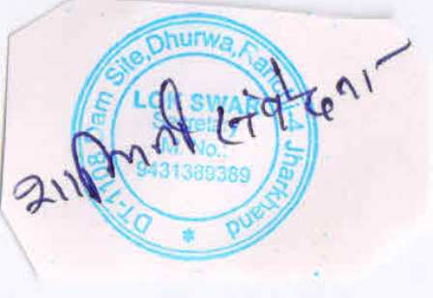
Shalini samvedna
Secretary
LOK SWAR
(Voice of people)

CONTENTS
Sl.No | Details | Page No
1 | ABOUT LOK SWAR | 4-6
1 | LOK SWAR’s background | 4
1 | Vision, Mission | 4
1 | General Objectives | 4-5
1 | Areas of Intervention | 5
1 | Thematic Issue | 5
1 | Referral groups | 6
3 | ORGANISATION RESOURCES | 6-6
3 | Assets & Infrastructure | 6
4 | OUR ENDEAVORS IN YEAR 2021-22 | 6-13
4 | Women & Girl Empowerment | 7
4 | Safe Migration | 8-9
4 | Maternal and Child Health | 9-10
4 | SRHR | 11
4 | Agriculture | 12
4 | Education | 13
5 | GOVERNANCE OF LOK SWAR | 14-15
5 | LOK SWAR’s Policies & Guidelines | 14
5 | Board meetings & Attendants | 15
5 | Board Members Details | 15
5 | Women Composition in the Organisation | 15
6 | OUR PARTNERS IN DEVELOPMENT | 16
7 | LEGAL STATUS/ ORGANIZATION PROFIEL | 16
8 | NETWORK AND LINKAGES | 17

ABOUT LOK SWAR

LOK SWAR’s background
As its name spells "LOK" means - People and “SWAR” means - voice, acronym is "voice of peoples". Organization was already working for women and girls, rights, since 1994, before it got legally registered in 2000 because core founders of organization were themselves victim of child marriage and physical violence & other types of GBV in their lives. Year 1994 was the time when these groups of women raised their voice against injustice that they were facing in their own life and others women lives of the area were they usually lived and hence it was decided to set up the organization, this was the first time that they came together as a formal association to give concrete shape to their ideas.

Vision
Lok swar’s mission is the establishment of caste- less. Class less society free from exploitation & oppression in which basic needs of the entire individual met with dignity. The values like mutual respect and assistance, confidence and brotherhood, gender equality, harmony and honesty prevail and practiced in the behaviour. Environment is free from pollution and not under risk of future damage due to the adoption of sustainable practices at larger scale by the societies and businesses

Mission
Continuously enlarge the network of socially constructive mechanism with a view to free India from shackles of poverty, backwardness, ignorance & injustice and to work as an instrument, a medium or a mechanism available for people (LOK) to raise their suppressed or yet unstated voice (swar) by raising their awareness beyond their traditional confines by focusing on critical variables restricting their development

General Objectives
- To promote education and awareness among the weaker sections of society;
- To instil confidence among adolescent girls and women so that they are able to take firm steps into future as strong citizens;
- To enable farmers to master over the vagaries of nature;
- To remove all types of pollutants not only from the food chain but also from the environments;
- Spread the entrepreneur-ship among the depressed regions

Areas of Intervention
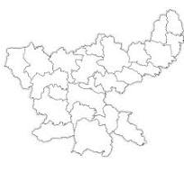
- Ranchi
- Khunti
- Hazaribag
- Ramgarh
- Dhanbad
- Bokaro
- Simdega
- Singbhum

Thematic issues

Livelihood
Child rights and education
Health & Nutrition
Women Empowerment
Promotion of natural resources in land & agriculture
SRHR
Realization of RTE act 2009
Women & Girls rights

Convergence with government support/ social security schemes & services
Proper service delivery
Strengthening SMC’s
Promotion of Income generation activities

Referral Groups
- Women & Girls
- Boys & Men
- Youths & Adolescents
- Lactating and Pregnant Mothers
- Scheduled Tribes, Scheduled Castes, minorities, Farmers
- Person with Disability (Dibyang)
- Ultra-Poor of all communities
- Other Economically Backward Groups

Organization Resources

Assets and Infrastructures
Well-equipped office in an area of 850 sq ft, All necessary office furniture including 20 chairs, 7 tables,2 almirah , 4 computers, 1 laptop, 2 printers, 1 scanners,1 projector, 3 motor cycles, 2 motor cars ,utensils ,Projector & screen -1, two motorcycles.
OUR ENDEAVORS IN YEAR 2021-22
Sn.no | PROGRAMS | Thematic Area | SUPPORTED BY
1 | Preventing and responding to child marriage and early unions | Gender Justice | Girls First fund
2 | Promotion of safe mobilization and counter trafficking | Livelihood | British Asian Trust
3 | District level workshop of front line health workers on RH blood incapability | Health | Conexus Foundation
4 | Awareness Camp for Adolescent Girls on Reproductive Health Rights | Health | Self-supported Program
5 | 1 day Panchyat level awareness program on integrated farming | Agriculture | Self-supported Program
6 | 1-day training program of SMcs on strengthening & quality implementation of RTE act | Education | Self-supported Program
Women & Girl Empowerment

Preventing and responding to child marriage and early unions project
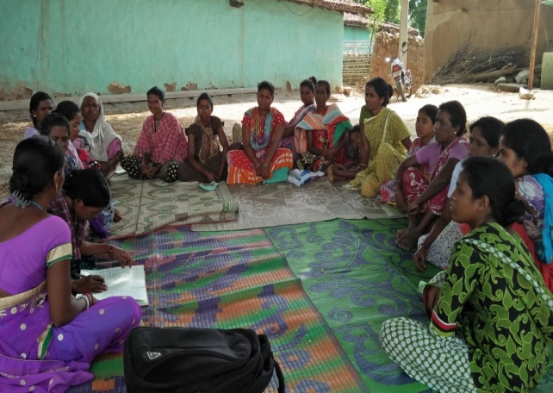
By and large the violence against women and girls is accepted in the State due to deep rooted patriarchy in all walks of life and child marriage is also one among such violation of rights among girls. Preventing and responding to child marriage and early unions project supported by GIRLS FIRST FUND via CAPITAL FOR GOOD USA aims to strike this patriarchal hegemony at its root and create an enabling and safe environment for girls’ holistic development in a supportive and progressive community in its intervention area at Khunti district of Jharkhand by addressing the disproportionate impact of gender-based violence on females. And by engaging major state players in discussion forums on changing social norms with prime focus on eradicating Domestic violence (dv) and child early forced marriage (CEFM)
Lok swar has been implementing this project from past 2 years in the field area of Khunti covering 10 villages, 2 panchyats of khunti block of Khunti district Jharkhand. Entire essence of the project that has been implemented is based on 3 pillars which revolve around engaging parents group, service provider group, and influencer groups of the community in support of the girls for stopping child marriage in the targeted area.
Target groups especially girls, parents (mother committees) boys, other stakeholders such as AWW, health workers, teachers, PRI members etc are involved through monthly activities such as theme based workshops, meetings, trainings, FGDs, sports activities, oath ceremonies, self-assessment activities etc.

-It also enables by equipping leadership skills in women & girls through series trainings, workshops, FGds, meetings in a joyful way, learnings & techniques, so that they themselves can turn up as a voice raiser against any injustice in any aspect of life along
with collaborating with other like-minded individuals, social organizations etc to spread the thought process & nobility of the efforts to wider mass/population

Success story
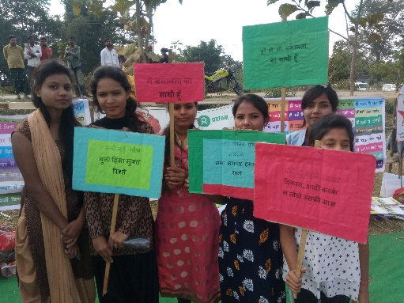
Child marriage was stopped by girls goup of chalagi village just before 3 days of cermony
Shreya, Deepa, Divya, & Gouri are the members of girls group of chalagi village, Khunti .LOK SWAR had laid its outmost effort in shaping inner confidence, eagerness & leadership skills of girls group of chalagi village, which ultimately
resulted/inspired them to stop child marriage in their village. Adolescent & youth girls group of chalagi village has stopped child marriage of a girl of 16 years of age in the village just before 3 days of ceremony. They dialled numbers of district authorities, they informed social organizations working in that particular area, and also informed to like-minded peoples of chalagi village. Group action taken by girls has demonstrated their awareness level, confidence & leadership skills & is a ray of hope for a minor girl child who was saved from being get married at minor age.

Safe Migration

Promotion of safe mobilization and counter trafficking
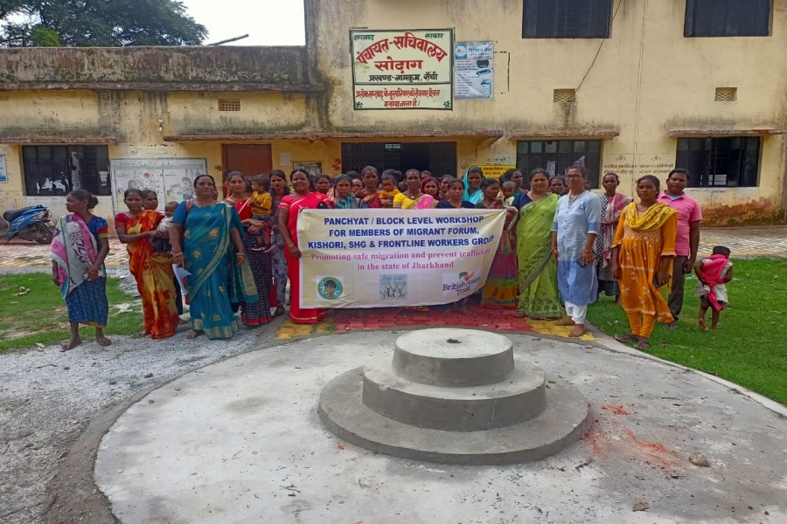
Promoting safe mobilization and counter trafficking is a project supported by BRITISH ASIAN TRUST which is being implemented by LOK SWAR in 10 villages of Namkum block of Ranchi district of Jharkhand state.
Followings are its core principles
- Ensuring safe migration in the state of Jharkhand
- Community based awareness campaign and providing information so that the community can solve the problems related to safe migration on its own.
- To establish coordination with the government and government officials for the implementation of laws related to safe migration.

This is being executed by forming different groups at village and panchayat levels such as migrant forums groups, women and girls groups and Imparting training through meetings, FGDs, workshops to village community members who go outside /migrate in search of job opportunity. In each village there is a group called migrant Forum formed at village, panchayat and block level. Training about Safe migration- Registration in block about going out of city. Information to family members, gram sabha about employer, type of benefit etc. Convergence of government social security schemes meant for daily wage workers/ majdoors etc
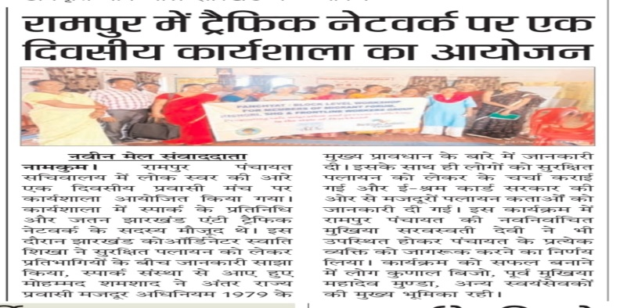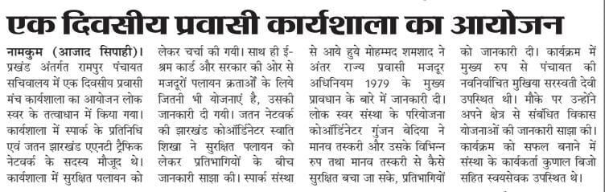

Maternal and Child Health

District level workshop of front line health workers on RH blood incapability
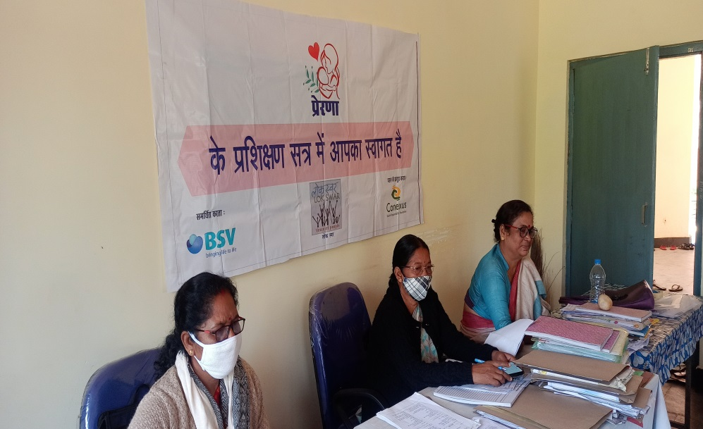
In 2021, LOK SWAR successfully conducted a comprehensive day-long workshop on Rh blood incompatibility across all 10 blocks of East Singhbhum district, Jharkhand. This initiative was specifically targeted at frontline health workers, including Anganwadi workers, ASHA workers, (ANMs), nurses, block-level health workers, and doctors. The primary objective was to enhance their understanding and awareness of Rh blood incompatibility, a critical health issue affecting mothers and new-borns

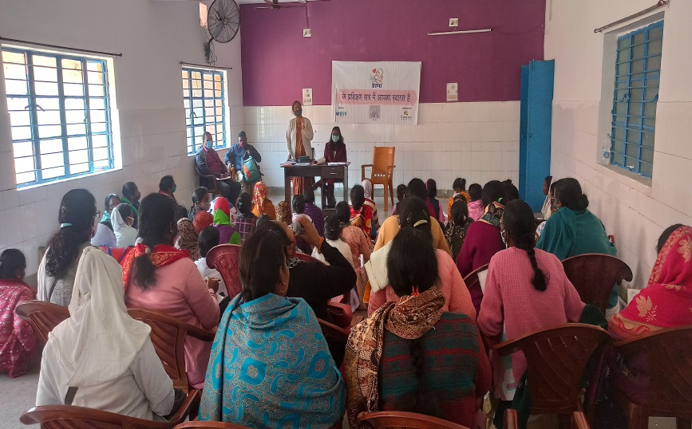
Rh blood incompatibility occurs when an Rh-negative mother carries an Rh-positive fetus, leading to potential complications during pregnancy. The Rh factor is a protein found on the surface of red blood cells. If the mother's blood is Rh-negative and the fetus's blood is Rh-positive, the mother's immune system may recognize the fetus's Rh-positive cells as foreign and produce antibodies against them. These antibodies can cross the placenta and attack the fetus's red blood cells, causing haemolytic disease of the new-born (HDN), which can lead to serious health issues such as anaemia, jaundice, or even heart failure in severe cases.
The workshop aimed to equip state government frontline health workers with essential knowledge to identify and manage cases of Rh incompatibility effectively. Key areas covered included:
Identification and Screening: Understanding the importance of early screening for Rh factor in pregnant women and the need for timely intervention.
Management and Treatment: Discussing the use of Rh immunoglobulin (RhIg) to prevent the formation of antibodies in Rh-negative mothers.
Counselling and Awareness: Training health workers to counsel expectant mothers on the risks of Rh incompatibility and the importance of regular antenatal check-ups.
Collaboration and Reporting: Encouraging inter-departmental collaboration to ensure comprehensive care for affected mothers and new-borns.
This workshop marked a significant step towards improving maternal and child health in the region by reaching 4832 health workers in all the 10 blocks of East singhbhum district. By empowering frontline health workers with crucial knowledge and skills, LOK SWAR ensured that they are better prepared to handle cases of Rh blood incompatibility, ultimately contributing to the reduction of maternal and neonatal morbidity and mortality. The initiative also fostered a deeper understanding of the importance of antenatal care and the role of health workers in safeguarding the well-being of mothers and children.

SRHR

Awareness Camp for Adolescent Girls on Reproductive Health Rights
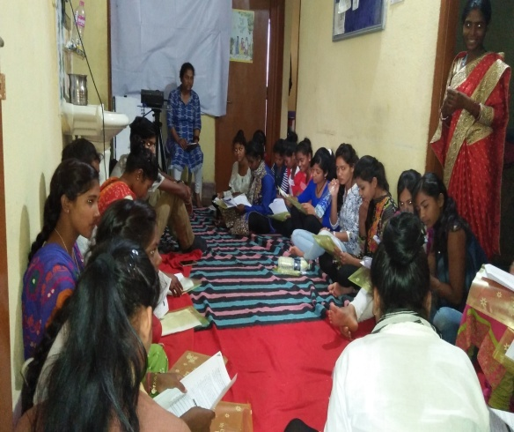
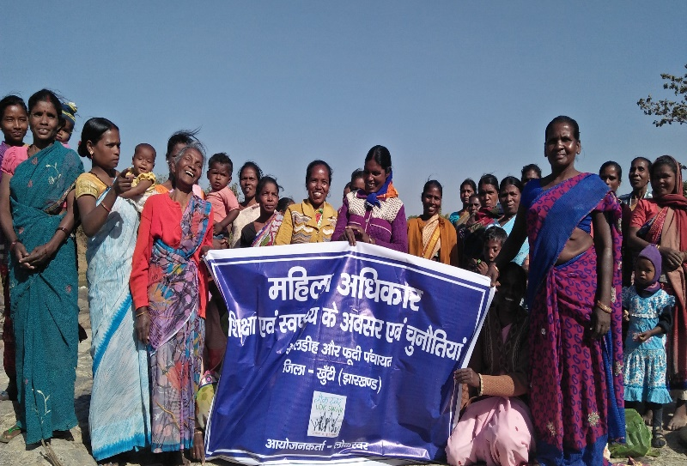
More than 26 million women and girls of reproductive age worldwide are in dire need of humanitarian aid, having been forced from their homes by violence and persecution, Jharkhand is also one of the most vulnerable and poverty-stricken states of India. There are limited programs and campaigns for communities that include gender and sexuality as prioritized public health concerns of adolescents and youth. Research by various agencies shows that young women’s & girls have limited knowledge on menstruation, sex, pregnancy, contraception, and abortion. Not only they have negligible information/awareness level on this, in fact majority of rural population of girls & women have even not heard that they have certain rights related to their desire, their body, their health etc. Looking this perspective into mind, LOK SWAR from past few years have started organizing awareness camps in its field area by involving adolescent girls, youth girls & women.
1-day awareness camp on information dissemination on SRHR components for girls was organized by inviting 20 girl leaders aged between 15 to 20 from 2 villages of LOK SWAR’S target area Khunti & 20 participants from women group in another 1-day awareness camp that was organized for women group members especially & separately. Information about 8 components that covers SRH RIGHTS was discussed with participants. However, discussion was not done in very depth; motto was to inform participants about their certain health rights & components that that fall under it. Formal discussion on following components was done & view of participants on the were recorded in order to know /map basic knowledge level of the participants about different topics

Agriculture

Panchyat level awareness program on integrated farming
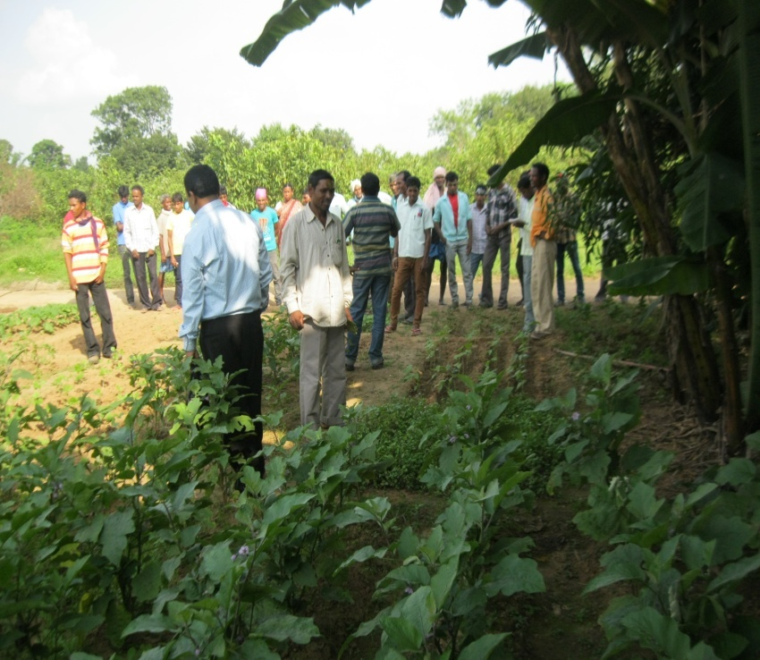
In the financial year 2021-22 Lok Swar organized 1 day Panchyat level awareness & capacity building program on organic farming & modern agriculture and its practices with a view to benefit the farmers about the modern & organic agriculture. 45 Farmers of Guthzora & Fuddi panchyat of Khunti Block of Khunti district participated in this program. Later on it was decided that all of 45 participants will be part of advance training & exposure tour program in Birsa Agricultural Collage Ranchi in next FY year
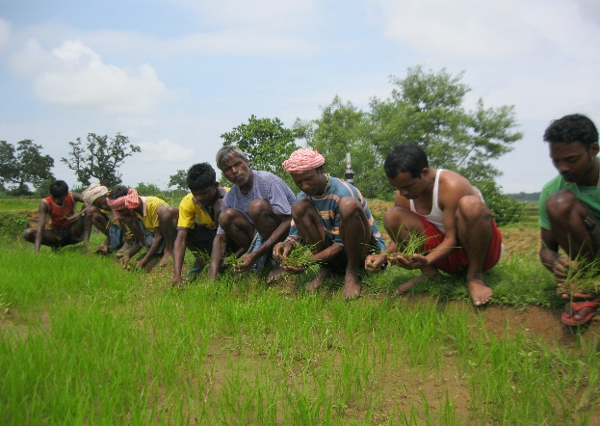
Mr. Suman Choybe & Mr. Krishna Rajgopalan of Birsa Agriculture collage Ranchi were resource person of this program. Resource person informed about various techniques of organic & modern farming, they laid emphasis on crop rotation, use of low input high yield sustainable plants with special emphasis on use of SHRI VIDHEE technique for rice cultivation. Total of 45 villagers participated in agriculture awareness program from both the district & got benefit from it by enhancing their knowledge on latest scientific techniques of organic farming/ agriculture

Plants distribution
Papaya | Mango | Lemon
450 | 280 | 325

Education

Training program of School management committee (SMCs) on strengthening & quality implementation of RTE act
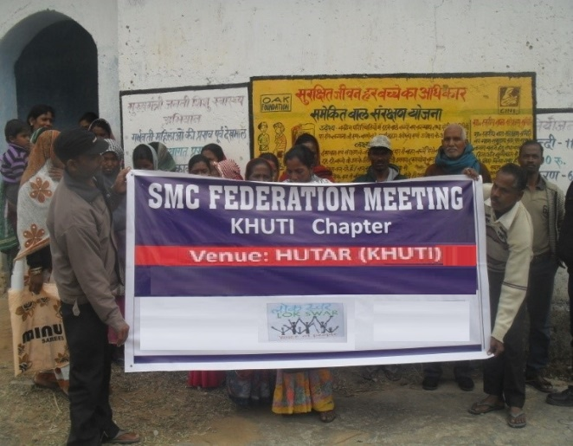
The main objective to organize this event was to build, strengthen capicity of district level SMC feedration & its members, with oreintation on RTE ACT 2009. The program was started with inaugration done by Mrs Shalini samvedna (secretary LOK SWAR).Mr. Prince kunal singh, coordinator of LOK SWAR (VOICE OF PEOPLE) welcomed members & leaders of SMC’s, mata committies & other participats of the program followed by Introduction of the participants & team member of lok swar. Mr Kunal informed participants about the pourpose & need of SMC feederation. Later on a breif oreintation session was conducted by Mrs Samvedna on RTE ACT 2009 followed by question & answer session by participants.
Followings are some main points, related to RTE act that were discussed in oreintation session

- Roles & resposibilities of SMCs
- Responsiblities of State government in context with RTE
- Responsibilities of schools & teachers
- Responsibilities of parents etc in context with RTE
- What is the importance/Need of SMC’s

Charter of demand by SMCs
- Avalability of more teachers as comparaision with student strength
- To up grade the quality of food which are being distributed in schools as mid day meal. Cheap quality of food are being distributed for children

GOVERNANCE OF LOK SWAR

LOK SWAR’s Policies & Guidelines
LOK SWAR believes in participatory approach of work and it is followed by organization, starting from community to organizational level. We go through community based micro plan for planning and development of the village in each of its programme. Within the organization, we have monthly staff meeting in which we take all the functional decisions. Core team has been constituted to take day to day functional and assets related decisions. LOK SWAR is governed by the manuals and policies
ORGANIZATIONAL POLICIES

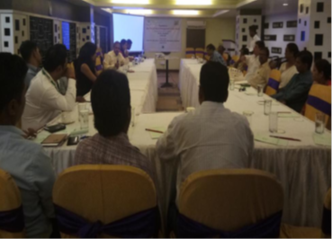
Board meetings & Attendants
As per the by-laws of LOK SWAR, annually two board meetings are mandatory, but extra number of meetings can be organized considering the needs of the organization. In the year 2020-21, we have organized 4 board meetings in which the 100% presence of board members has been recorded.
Name | Name of Father/  Husband | Nationality | Occupation | Designation | Address
Mr. Ashok krsrivastav | Late K.K Srivastav | Indian | Self employed | President | Near House no DT 1840  Tanki side Dhurwa Ranchi-4
Shalini Savavedna | Sidheswar Singh | Indian | Social Activist | Secretary | D.T 1108 Dhurwa, Ranchi-4
Srawan Kr. Giri | Lt. SukhdevGiri | Indian | Self employed | Member | DT-1414 Dam Side Dhurwa
Sarita Tirki | Shri. AppaRao | Indian | Self employed | Member | Sh. AppaRao, Jagannath Flower Mill, dhurwa, Dam Side
Rita Singh | Suresh Singh | Indian | House wife | Member | C/o –Shiv Bachan Singh, DT-1386, Dhurwa Dam Side
Mrs sandhya pandey | Mr.GaganPandey | Indian | Social activist | Member | Boreya village Kanke Ranchi
Mrs sangeeta Toppo | Mr Mahesh Toppo | Indian | House wife | Member | Kanke Block campus Ranchi
Sanjay Kumar Sharma | Late Dr Mahesh Sharma | Indian | Social Activist and Professor | Member | J- 235 Patel Nagar Gaziabad UP
Board Members Details

Women Composition in the Organisation

Programme and Administrative Staff Male Female Total

Board Members 3 5 8
Number of Full Time Staffs 2 4 6
Number of Part Time Staffs 1 2 3
Number of Paid Volunteers 17 19 36
Number of Consultant 1 1 2
Total 21 26 47

OUR PARTNERS IN DEVELOPMENT FOR FY 2021-22
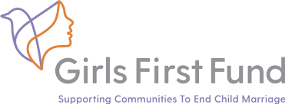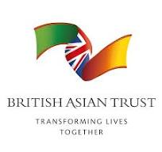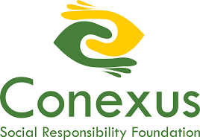

LEGAL STATUS/ ORGANIZATION PROFIEL
LEGAL INFORMATION
Name of the organization | LOK SWAR (VOICE OF PEOPLE)
Address (head office) | In front of sudarshan foods, B III 580,Dhurwa dam side road ranchi , Jharkhand
Address (Registered office) | Hn.no BIII 580 ,Dhurwa Bus stand Ranchi-4 Jharkhand
Contact No (o) | (m)- 9693457639, 8210437895 9431389389,  Email – lokswar@yahoo.co.in
Website | www.lokswar.org
Contact person | Shalini samvedna (Secretary), Prince Kunal (Coordinator)
Legal Status | Registered under the Indian Trust Act 1882,  Registration no- 8126, 12A
Date of Registration | 3 August 2000
Year of Registration under FCRA | 2004 (on 22nd march) Renewal completed in 2016 & 2021
F.C.R.A No | 337800123
F.C.R.A Validity | From 01-01-2022 to 01-01-2027
PAN No. | AAATL3536E
80 G | AAATL3536EF20221
80 G Validity | From 24-05-2022 to AY 2025-2026
12 A | AAATL3536EE20214
12 A Validity | From AY 2022-23 to AY 2026-27
TAN No | RCHL00419G
Governing Board members | Consists of 10 members (3 males) & (7 Females)
Name of Banks | General Account - Punjab National Bank,  FCRA Account - SBI N.D.M.B  H.E.C sector 3,Dhurwa  Branch, A/C No – LOK SWAR (0404000100335282)  FCRA Account - Bank of India, Main Branch  Albert Ekka Chowk, Ranchi  A/C No- LOK SWAR (490010100033988)  IFSC - BKID0002
NETWORK AND LINKAGES

S.no | Name of Network | S.no | Name of Network
1 | Wada Na Todo Abhiyan | 9 | GIRLS NOT BRIDE
2 | National Alliance of Women | 10 | Jharkhand Right to education Forum
3 | Sukhar Virodh iAbhiyan | 11 | NAREGA Watch team (Jharkhand)
4 | Bal Majdori Virodhi Abhiyaan | 12 | WOMEN’S TASK FORCE
5 | SRHR ALLIANCE INDIA | 13 | Jharkhand Anti Trafficking Network
6 | Rashtriya Karigar Panchyat | 14 | TAAC HUB
7 | Right to Food Campaign | 15 | IPACHA INDIA
8 | Indian Peoples’ Theatre Association Jharkhand (IPTA) | 16 | BACHPAN BACHAOO ANDOLAN

